
Ras (G13R)
Catalog Number: CR-M26474
Gene Symbol: H-Ras; K-Ras; N-Ras
Description: Anti-RAS (G13R) Mouse Monoclonal Antibody

Background: Ras protein is a
membrane-associated GTPase signaling protein that regulates proliferation, differentiation, and
cell survival. Ras G13R mutation result in
decreased GTPase activity and constitutive
signaling, and is correlated with the development of pancreatic intraepithelial neoplasia and lung
lesions.
Immunogen: A synthetic peptide from the internal region of Ras which includes the mutation of G13R, human origin.
Tested applications: ELISA,WB,IF, IHC Recommended dilutions:
ELISA: 1:1000-1:5000
WB: 1:500-1:1000
IF: 1:50-1:100
IHC: 1:20-1:100
Concentration: 1 mg/ml
Host: Mouse
Clonality: Monoclonal
Purity: Purified from ascites
Format: Liquid Storage buffer:
Preservative: no
Constituents: PBS (without Mg2+ and Ca2+), pH 7.4, 150 mM NaCl, 50% glycerol
Species Reactivity: Recognizes G13R mutant, but not wild-type RAS of vertebrates.
Storage Conditions: Store at -20°C. Avoid freeze / thaw cycles.

Western blot:
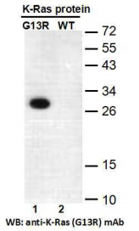
Western blot analysis of recombinant HRas (G13R) and wildtype proteins. Purified
His-tagged Ras (G13R) protein (lane 1) and corresponding wildtype protein (lane 2) were blotted with anti-Ras (G13R) monoclonal
antibody (Cat. #26474).

For research use only. Not for diagnostic or therapeutic applications.

Immunofluorescence:
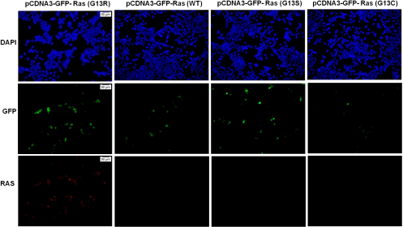

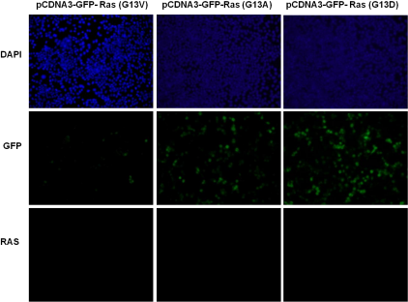
Immunofluorescence of cells expressing Ras proteins with anti-Ras (G13R) antibody. HEK293T cells were transfected with pCDNA3-GFP-Ras (G13R) plasmid ,pCDNA3-GFP-Ras (WT) plasmid,
pCDNA3-GFP-Ras (G13S) plasmid , pCDNA3-GFP-Ras (G13C) plasmid , pCDNA3-GFP-Ras (G13V) plasmid , pCDNA3-GFP-Ras (G13A) plasmid ,
or pCDNA3-GFP-Ras (G13D) plasmid , then fixed and stained with anti-Ras (G13R) monoclonal antibody (Cat. #26474).

